Exercise 01:
Given the following network:
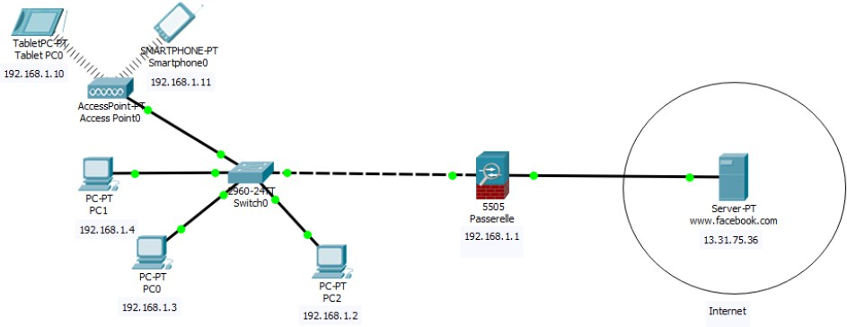
- What is the class of IP addresses for the machines in the local network? Why?
@ Network: 192.168.1.0 / 24 ==== 11000000.10101000.00000001.00000000
Masque 24, it means : 11111111 . 11111111 . 11111111 . 00000000
@ IP 192.168.1.1 : 11000000.10101000.00000001.00000001
@ IP 192.168.1.2 : 11000000.10101000.00000001.00000010
@ IP 192.168.1.2 : 11000000.10101000.00000001.00000011
CLASS C because all these addresses belong to : [192.0.0.1 -- 223.255.255.254]
Or: C Class ; 192 : 11000000

- What is the subnet mask to assign to each machine to be part of the same LAN?
255.255.255.0, the default subnet Mask for Class C
Masque 24, it means : 11111111 . 11111111 . 11111111 . 00000000
- Provide the other configurations for the machines.
Add the gateway to each machine: 192.168.1.1
- What is the difference between machines connected via Wi-Fi and those connected to the switch? Explain the operation of both connections.
WIFI: a single collision domain: the smartphone and the tablet cannot communicate at the same time without message loss, so a multiple access protocol with carrier sensing and collision detection/avoidance is required for frame transmission.
Switch; switched Ethernet: Each exchange can occur at nominal speed (no sharing of bandwidth), without collisions, resulting in a significant increase in network bandwidth (at equal nominal speeds). All ports of a switch can communicate simultaneously without message loss.

- What is the role of the ARP protocol?
Communication between machines can only occur through the physical interface. Applications only know IP addresses! ARP allows for establishing the link between IP addresses and physical addresses.
- Explain how this protocol helps the smartphone connect to Facebook and receive responses from it.
a. The smartphone broadcasts the IP address of the gateway on the physical network in search of its MAC address (ARP request).
b. The machine with the concerned IP address (the gateway) sends a message to the smartphone containing its physical address (ARP response).
c. The other machines on the LAN do not respond.
d. The smartphone saves this correspondence (192.168.1.1/Gateway MAC) in its cache to avoid making an ARP request for each transmission.
e. Now that the smartphone has the MAC address of the gateway, it can connect to the Facebook server through this gateway. Note: for the response from Facebook, it is the gateway that will search for the MAC address of the smartphone to provide the response.
- Provide the source and destination IP addresses, as well as the source and destination MAC addresses of the ARP requests and responses.
ARP Request: IP source: 192.168.1.11, IP destination: 192.168.1.1, MAC source: MAC Smartphone MAC destination: FF:FF:FF:FF:FF
ARP Response IP source: 192.168.1.1 IP destination: 192.168.1.11 MAC source: MAC Gateway (the one being searched) MAC destination: MAC Smartphone
- Give three scenarios where the ICMP protocol is involved.
• Facebook Machine Disconnected (ICMP error sent to the source: smartphone)
• Datagram lifetime expired (TTL) before reaching the Facebook server (ICMP error sent to the source: smartphone)
• Congestion in intermediate routers leading to the server (ICMP error sent to the source: smartphone)
• Perform an ICMP ping from the smartphone to the server (ICMP verification)
- What command should PC1 enter to know the complete path to the Facebook server? How does this command work?
• Traceroute www.facebook.com (Unix),
• Tracert www.facebook.com (Windows)
The traceroute/Tracert command provides output describing the names and IP addresses of successive routers, preceded by a sequence number and the minimum, average, and maximum response times. Operation: uses incremented TTLs.

Exercise 02: Cisco CCNA Questions
- A technician uses the command ping 127.0.0.1. What does the technician want to test?
  - The connectivity between the PC and the default gateway
  - The connectivity between two PCs on the same network
  - The connectivity between two adjacent Cisco devices
  - The physical connectivity of a specific PC to the network
  - The TCP/IP stack on a host in the network
- What does a Layer 2 switch do when the destination MAC address of a received frame is not in its MAC table?
  - It transmits the frame to all ports except the port on which the frame was received.
  - It initiates an ARP request.
  - It sends the frame to all ports of the switch.
  - It informs the sending host that the frame cannot be delivered.

- Which address on a PC never changes, even if the PC is moved to another network?
  - The MAC address
  - The default gateway address
  - The IP address
  - The logical address
- What will happen if the default gateway address is misconfigured on a host?
  - The switch will not forward packets initiated by the host.
  - The host cannot communicate with hosts on other networks.
  - A ping request from the host to the address 127.0.0.1 will fail.
  - The host cannot communicate with other hosts on the local network.
  - The host will need to use the ARP protocol to determine the address of the default gateway.
- What method is used to manage collisions on a wireless network?
  - Priority order
  - CSMA/CA
  - CSMA/CD
  - Token passing
- Which IPv4 packet header field never changes during transmission?
  - Time to live
  - Destination address
  - Packet length
  - Indicator
- Which address does the network card use to decide whether to accept a frame?
  - Source IP address
  - Destination IP address
  - Destination MAC address
  - Source MAC address
  - Source network address
- Which statement describes the function of the Address Resolution Protocol (ARP)?
  - ARP is used to discover the MAC address of any host on the local network.
  - ARP is used to discover the IP address of any host on the local network.
  - ARP is used to discover the IP address of any host on a different network.
  - ARP is used to discover the MAC address of any host on a different network.
- A computer in a given network communicates with a specific group of computers. What type of communication is this?
  - Broadcast
  - Multicast
  - ARP
  - Unicast
  - HTTP
- Which statement is true regarding MAC addresses?
  - MAC addresses are implemented by software.
  - The first three bytes are used to uniquely identify a manufacturer or organization.
  - ISO is responsible for regulating MAC addresses.
  - A network card does not need a MAC address if it is connected to a WAN.
- What are the two potential network problems that can arise from ARP operation? (Choose two answers.)
  - Attackers could manipulate the mapping of MAC and IP addresses in ARP messages with the intent of intercepting traffic on the network.

  - Manually configuring static ARP associations could facilitate ARP poisoning or MAC address spoofing.
  - On large low-bandwidth networks, multiple ARP broadcasts could cause data communication delays.
  - Multiple ARP responses cause the switch's MAC address table to contain entries corresponding to the MAC addresses of hosts connected to the switch ports.
  - A large number of broadcast ARP requests could cause the host's MAC address table to overflow, preventing it from communicating on the network.
- What are the two characteristics of ARP? (Choose two answers.)
  - If the device receiving the ARP request has the destination IPv4 address, it sends an ARP response.
  - If a host is ready to send a packet to a local device with the IP address but not the destination MAC address, it generates a broadcast ARP.
  - An ARP request is sent to all devices on the local Ethernet network and contains the destination host's IP address and the multicast MAC address.
  - When the host encapsulates a packet in a frame, it refers to the MAC address table to determine the mapping of IP addresses to MAC addresses.
  - If no device responds to the ARP request, the originating node will broadcast the data packet to all devices on the network segment.
- Which subnet includes the address 192.168.1.96 as a usable host address?
  - 192.168.1.64/26
  - 192.168.1.32/27
  - 192.168.1.32/28
  - 192.168.1.64/29
- What are the three private IP addresses? (Choose three answers.)
  - 192.167.10.10
  - 192.168.5.5
  - 172.32.5.2
  - 10.1.1.1
  - 172.16.4.4
  - 224.6.6.6

